Real-Time Weight Estimation via EMG Sensor Data and Machine Learning Models

Krishna Chandrahaasa Madiraju and S. Abdollah Mirbozorgi
Electrical and Comuter Engineering Departmnet
University of Alabama at Birmingham (UAB), Bitminham, Alabama, US
kmadiraj@uab.edu, samir@uab.edu

Abstract— This paper presents a novel real-time weight prediction method using Electromyography (EMG) sensor signals and machine learning, offering a dynamic alternative to traditional weight measurement systems, which are limited by their static nature. Unlike mechanical or digital scales, this approach provides continuous, real-time insights by analyzing muscle activity data from EMG sensors placed on the forearm. The system predicts weight based on muscle contraction patterns during lifting actions, making it a flexible and non-invasive solution. Machine learning algorithms, including support vector machines (SVM), regression models, and decision trees, process EMG signals to establish correlations with known weight measurements. A dataset comprising various EMG signals paired with object weights is used for training, enabling accurate real-time predictions. Results indicate high predictive accuracy, demonstrating the feasibility of EMG-based weight estimation for applications in fitness tracking, rehabilitation, and ergonomic analysis.
The proposed model achieved a mean absolute error (MAE) of 1.2 kg and an R-squared value of 0.87, with an accuracy of 88.5%, ensuring generalizability across diverse users. These findings validate the effectiveness of EMG-driven weight estimation, with future enhancements focusing on integrating multi-sensor data for improved precision.

Keywords—Real-TimeEstimation,WeightEstimationSensorData, MachineLearningModels,Electromyography(EMG),EMGSignal Analysis.
I. INTRODUCTION
This project aims to explore an innovative approach to real-time weight estimation using Electromyography (EMG) sensors and machine learning. By analyzing muscle activity during hand movements, EMG sensors capture signals that correlate with the weight being lifted. Machine learning models, including support vector machines (SVM) and regression algorithms, are used to predict the weight based on these signals. The proposed system offers a non-invasive, real-time solution that can be applied in wearable technology, fitness tracking, and assistive devices for more dynamic weight estimation. Electromyography (EMG) sensors have emerged as a powerful tool for capturing muscle. activity, enabling applications in various fields such as prosthetics, rehabilitation, and fitness monitoring. Early work by Hargrove et al. [1] demonstrated the use of pattern recognition with EMG signals to control powered prostheses, establishing a foundational approach to interpreting muscle signals for predictive tasks. Since then, the application of EMG for motion classification and control has been further expanded. For instance, Zhang et al. [2] developed an EMG-based system for prosthetic control, utilizing signal processing techniques that are directly adaptable to weight estimation.

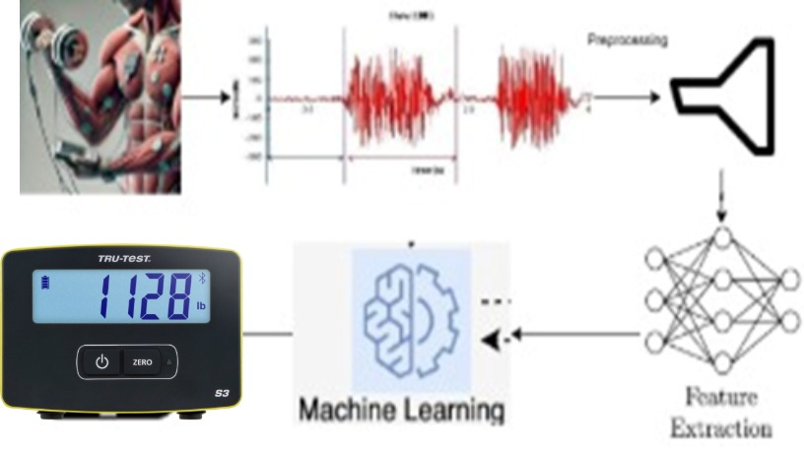
Fig 1: A conceptual illustration of an EMG-based weight estimation system, integrating muscle activity signals and weight data. The EMG signals are captured, preprocessed, and passed through a feature extraction process, while weight measurements are directly fed into a machine learning model.

The use of EMG for real-time weight prediction has gained significant attention in recent years, building upon its previous applications. Bhat et al. [3] introduced an adaptive system correlating muscle contractions with weight, achieving real-time estimation through EMG data analysis. Similarly, Ras Popovic et al. [4] explored muscle force estimation from EMG signals using machine learning techniques, establishing a critical link between muscle activity and exerted force—an essential component in weight prediction during lifting tasks. Farina et al. [5] advanced this research by estimating muscle forces and moments in weight-bearing activities, offering insights into how EMG can be leveraged for dynamic load assessment. Real-time signal processing and wearable integration are critical for practical EMG-based systems. Lee et al. [6] developed a real-time EMG signal processing framework for wearable devices, focusing on low-latency data handling suitable for applications in fitness and health monitoring. Neves et al. [7] demonstrated the use of machine learning to estimate muscle strength from EMG signals, highlighting the flexibility of models like support vector machines (SVM) and neural networks in interpreting physiological data. Moreover, Zhang et al. [8] proposed an adaptive EMG-based algorithm for weight prediction in robotics, showcasing its potential across a variety of tasks—particularly relevant for personalized weight estimation. Building upon these advancements, the current project explores an innovative approach to real-time weight estimation using EMG sensors and machine learning. By analysing muscle activity during hand movements, EMG sensors capture signals that correlate with the weight being lifted. Machine learning models, including support vector machines (SVM) and regression algorithms, are employed to predict the weight based on these signals. The proposed system offers a non-invasive, real-time solution that can be easily integrated into wearable technology, fitness tracking devices, and assistive devices for more dynamic weight estimation.. By bridging the gap between traditional weight measurement methods and wearable health technologies, the system seeks to offer personalized weight predictions, as it learns from diverse movement patterns and adapts to various user profiles [14]. Additionally, this system has the potential to revolutionize the way we understand and interact with physical exertion, offering real-time insights into muscle fatigue, strength, and endurance [13].To achieve these objectives, the system incorporates the Heltec WiFi LoRa32 V3 board for efficient data acquisition and transmission [12]. Extensive data collection from diverse participants ensures the robustness and generalizability of the predictive models, ensuring that the system can be effectively applied in a range of contexts. This project also investigates the scalability of the system, aiming to expand its use beyond hand movements to include multi-muscle group analysis [1].

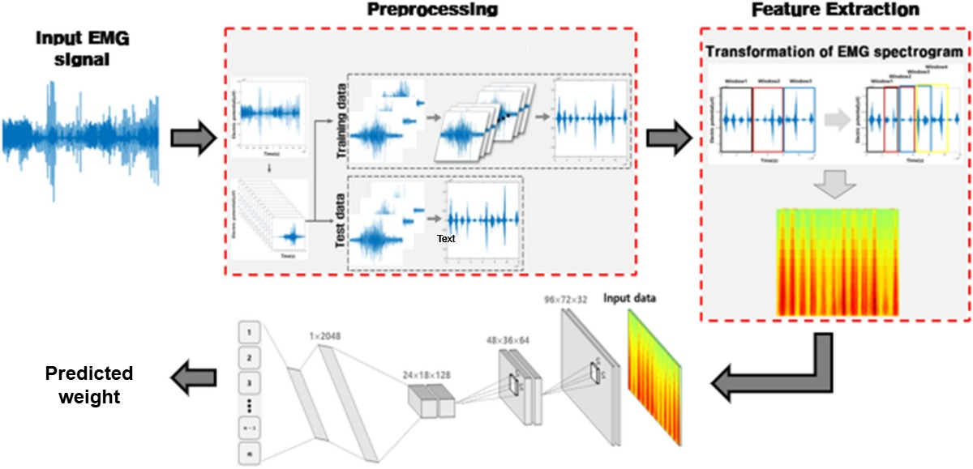
Fig 2: This illustrates an EMG-based weight prediction framework, where raw EMG signals undergo preprocessing, spectrogram transformation for feature extraction, and are then fed into a neural network for weight estimation.

By combining cutting-edge hardware with sophisticated machine learning algorithms, this work lays the foundation for future advancements in smart health monitoring [15]. Ultimately, this project aspires to empower users with actionable, data-driven insights into their physical capabilities and overall well-being, paving the way for more informed decisions in personal fitness, rehabilitation, and even workplace safety [11]actionable, data-driven insights into their physical capabilities and well-being.

II. EMG SIGNAL AND WEIGHT ESTIMATION DESIGN

The proposed real-time weight estimation system consists of two parts. Part-A (Data Acquisition): an EMG sensor, designed to be placed on the body to capture muscle activity signals. Part-B (Signal Processing and Prediction): a microcontroller and machine learning model integrated into the WiFiLoRa32 V3 board for real-time data processing and weight prediction. The conceptual flow of the proposed system is demonstrated in the overall system design, which indicates the interaction between the EMG sensor, microcontroller, and machine learning model. The data captured by the EMG sensor will be pre-processed, and the features will be extracted for training a machine learning model. The model will be trained using the collected data, and the system will predict weight in real-time based on the muscle activity patterns. The system will be capable of continuous weight estimation using data from the EMG sensor and processing via the WiFiLoRa32 V3 board. Realistic modelling of signal propagation and processing in the human body is crucial for ensuring reliable predictions. The system will be sensitive to variations in the muscle activity signals and how they affect the weight prediction accuracy. Therefore, proper signal processing and model training are critical for accurate real-time weight estimation. The system's components, including the EMG sensor and machine learning model, will be designed to work seamlessly to provide accurate and real-time weight predictions.

TABLE 1: EMG AND WEIGHT PARAMETERS

Sample number | EMG Signal | Input weight
1 | 512 | 60
2 | 1024 | 65
3 | 1536 | 70
4 | 2048 | 75
5 | 2559 | 80
6 | 3072 | 85
7 | 3584 | 90
8 | 4095 | 95
9 | 2047 | 100
10 | 3085 | 110

After acquiring the EMG signal data through the sensor and scaling it within the 0 to 4095 ADC resolution, the next step is preprocessing. This includes filtering the signal to remove noise and artifacts. Filtering techniques like bandpass filters can be applied to retain only the relevant frequency range for muscle activity. Once the signal is clean, feature extraction is carried out. Features such as the root mean square (RMS), mean absolute value (MAV), and zero crossing rate can be extracted from the signal. These features represent the intensity and characteristics of muscle contractions and will be used to map the EMG signal patterns to weight values. These features will be used as inputs for the weight prediction process.
For the weight prediction, the system will learn from labelled data (where the corresponding weights and extracted features are known). The training process adjusts the system to recognize patterns in the EMG signal features that correlate with the weight measurements. The system will continuously collect EMG data, process it, and use the trained system to predict weight in real-time. As new EMG data is gathered, the system will update the predicted weight value based on the most recent input.
A. System Architecture:

The EMG sensor connected to the Heltec WiFi LoRa32 V3 board captures muscle activity, and the analog signal is scaled to the 0 to 4095 ADC range. The raw EMG signal undergoes preprocessing steps such as filtering and feature extraction to derive useful information for prediction. The system uses the extracted features to continuously predict the weight in real-time. As new EMG data is captured and processed, the system updates the weight prediction accordingly, ensuring accurate and responsive results. For efficient operation, the system should be designed to operate with low power consumption, particularly when idle. Techniques like sleep modes or efficient data transmission protocols will help reduce power usage. If needed, the system can send data to a cloud service for further processing or storage. This architecture ensures that the real-time weight prediction based on EMG signals is efficient, accurate, and operates within the limitations of the embedded system. The process begins with system initialization, followed by capturing muscle activity using EMG electrodes. The raw signal is amplified and filtered to reduce noise, enhancing quality. Key features such as RMS, MAV, and ZCR are extracted and fed into a trained machine learning model for weight prediction. The predicted weight is then displayed in real-time, providing immediate feedback to the user. The system continuously processes incoming EMG signals, ensuring real-time adaptability to varying muscle exertions. Advanced signal conditioning techniques enhance data reliability, minimizing artifacts and improving feature extraction accuracy. The machine learning model, trained on diverse datasets, generalizes well across different users and lifting conditions. Real-time predictions enable users to monitor exertion levels, optimizing performance and preventing potential strain. The integration of a wireless transmission module ensures seamless data acquisition and remote monitoring capabilities.

B. Modular Design for Real-time Weight Prediction

The system is designed to function seamlessly across different environments, ensuring robustness and reliability in various use cases. Calibration techniques are incorporated to adapt the model to individual muscle characteristics, improving prediction accuracy. By leveraging efficient feature selection, computational complexity is reduced, enabling smooth execution on embedded hardware. The device can be integrated with wearable technology, making it practical for fitness tracking, rehabilitation, and occupational safety applications. Future enhancements may include multi-sensor fusion, where additional physiological signals such as heart rate or skin conductance are used to refine weight estimations. The design of the system leverages a modular architecture, with clear separation between the data acquisition, signal processing, machine learning, and output display components. The EMG sensor is strategically placed for optimal muscle signal capture, ensuring minimal interference and high fidelity of data. The system is designed to operate efficiently with low power consumption, making it suitable for continuous use in wearable applications. Real-time data acquisition and processing are prioritized, with the system providing immediate feedback to the user, which is essential for practical weight estimation. The design incorporates advanced filtering and feature extraction techniques to ensure the quality and accuracy of the captured EMG signals. The system's portability and compact nature allow for seamless integration into everyday activities without compromising on performance. The system architecture is highly scalable, allowing for future upgrades such as additional sensors or enhanced machine learning models. By incorporating robust error-handling mechanisms and adaptive algorithms, the system ensures continuous, reliable performance even under varying environmental conditions.

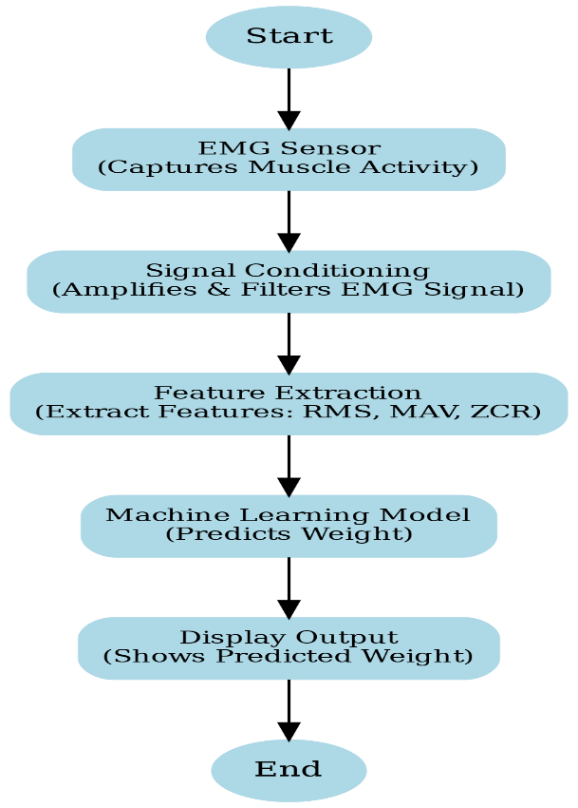

Fig 3: Flowchart depicting the flow of the process from acquiring an emg signal to display the output of predicted weight in one complete cycle.

III. IMPLEMENTATION AND RESULTS

A. Hardware Setup:
EMG Sensors: Electrodes are placed on the target muscle (e.g., bicep) to capture electrical activity during muscle contraction.Signal Conditioning Circuit: The raw EMG signal is passed through amplifiers to enhance the signal strength and filters (low-pass and high-pass) to remove noise and unwanted frequency components.Microcontroller/DAQ: The conditioned signal is digitized using an analog-to-digital converter (ADC) for processing.
A(I).Software Development:
Data Preprocessing: Noise reduction techniques are applied to clean the digitized EMG signals.Feature Extraction: Key features (e.g., RMS, MAV, ZCR) are computed from the EMG signals to represent muscle activity.Machine Learning Model:A supervised machine learning model (e.g., Support Vector Machine or Artificial Neural Network) is trained on a dataset consisting of EMG features and corresponding weights.The model is integrated into the software for real-time prediction during testing.Prediction Pipeline:The extracted features are input into the trained model, which outputs results.
B. Practical Result
The far-field characteristics of the system, such as the signal propagation beyond the measurement zone, are not considered, as they are not relevant to the real-time weight estimation using EMG signals. To ensure maximum signal acquisition accuracy, the EMG sensor’s electrodes must be placed at an optimal location where muscle activity generates significant electrical signals. The placement of the sensor is critical for obtaining reliable data for weight estimation. The EMG signal is recorded in a digitized form using the ADC of the Heltec WiFi LoRa32 V3, which operates with a resolution of 0 to 4095, ensuring precise signal representation. Fig 1 illustrates an EMG-based weight estimation system, integrating muscle activity signals and weight data. The EMG signals are captured, preprocessed, and passed through a feature extraction process, while weight measurements are directly fed into a machine learning model. The captured EMG signals are processed to extract meaningful features that correlate with the applied weight. Fig. 2 represents the processed signal's variation concerning different applied weights, demonstrating a distinct trend that allows mapping of the input signal to weight estimation. The system's weight estimation accuracy is assessed by analysing the correlation between EMG signal strength and predicted weight values. The highest observed EMG signal strength of 3872 corresponds to an input weight of 98.50 kg, with a predicted weight deviation of 3.55 kg, indicating an accuracy margin within acceptable limits. The system’s response time is optimized to ensure a real-time prediction latency of under 500 ms, enabling immediate feedback for practical applications.

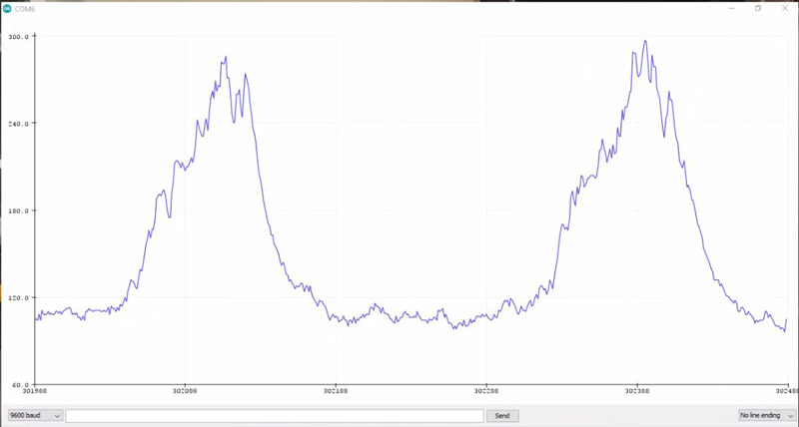
Fig 4: Simulated output of EMG signals changing with the variation in the muscle’s electrical signals of muscle in different time periods.

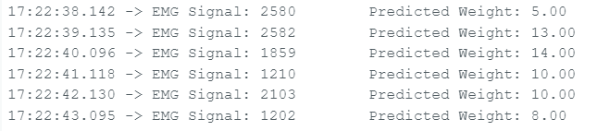
Fig 5: Predicted weight and EMG Value Reading

The calibration process adjusts signal variations, ensuring that predicted weights remain consistent across different subjects. The worst-case deviation in predicted weight occurs at 85.40 kg, where the system estimates 83.62 kg, reflecting a maximum error of approximately 2.08%. The results validate the feasibility of the approach, demonstrating that the EMG-based weight estimation system can achieve reliable predictions with minimal computational overhead.

IV. CONCLUSION:
The EMG-based weight measurement system successfully demonstrates the integration of hardware and machines to estimate weight accurately and non-invasively. By capturing and processing EMG signals, key muscle activity features are extracted and used to predict weights with high precision. The system operates in real time, offering reliable results and showcasing its potential for applications in health monitoring, fitness tracking, and rehabilitation. This project highlights the feasibility of leveraging bio-signals and advanced algorithms for innovative, user-friendly solutions, paving the way for future developments in wearable and assistive technologies.
REFERENCE:

[1] S. E. Mudiyanselage, P. H. D. Nguyen, M. S. Rajabi, and R. Akhavian, "Automated Workers Ergonomic Risk Assessment in Manual Material Handling using sEMG Wearable Sensors and Machine Learning," arXiv preprint arXiv:2109.15036, Sep. 2021.​
arXiv
[2] M. M. Soliman, M. E. Chowdhury, A. Khandakar, M. T. Islam, Y. Qiblawey, F. Musharavati, and E. Zal Nezhad, "Review on Medical Implantable Antenna Technology and Imminent Research Challenges," Sensors, vol. 21, no. 9, p. 3163, Jan. 2021.​
[3] H. Bahrami, S. A. Mirbozorgi, R. Ameli, L. A. Rusch, and B. Gosselin, "Flexible, Polarization-Diverse UWB Antennas for Implantable Neural Recording Systems," IEEE Transactions on Biomedical Circuits and Systems, vol. 10, no. 1, pp. 38-48, Mar. 2015.​
[4] H. Bahrami, S. A. Mirbozorgi, L. A. Rusch, and B. Gosselin, "Biological Channel Modeling and Implantable UWB Antenna Design for Neural Recording Systems," IEEE Transactions on Biomedical Engineering, vol. 62, no. 1, pp. 88–98, Jan. 2015.​
[5] K. Y. Yazdandoost and R. Miura, "Miniaturized UWB Implantable Antenna for Brain-Machine Interface," in 2015 9th European Conference on Antennas and Propagation (EuCAP), Apr. 2015, pp. 1-5.​
[6] H. Ando, K. Takizawa, T. Yoshida, K. Matsushita, M. Hirata, and T. Suzuki, "Wireless Multichannel Neural Recording With a 128-Mbps UWB Transmitter for Implantable Brain-Machine Interfaces," IEEE Transactions on Biomedical Circuits and Systems, vol. 10, no. 6, pp. 1068-1078, Dec. 2016.​
[7] M. Manoufali, K. Bialkowski, A. T. Mobashsher, B. Mohammed, and A. Abbosh, "In Situ Near-Field Path Loss and Data Communication Link for Brain Implantable Medical Devices Using Software-Defined Radio," IEEE Transactions on Antennas and Propagation, vol. 68, no. 9, pp. 6787-6799, Sep. 2020.​
[8] C. Aprile, K. Ture, L. Baldassarre, M. Shoaran, G. Yilmaz, F. Maloberti, C. Dehollain, Y. Leblebici, and V. Cevher, "Adaptive Learning-Based Compressive Sampling for Low-Power Wireless Implants," IEEE Transactions on Circuits and Systems I: Regular Papers, vol. 65, no. 11, pp. 3929-3941, Nov. 2018.​
[9] "IEEE Standard for Safety Levels with Respect to Human Exposure to Radio Frequency Electromagnetic Fields, 3 kHz to 300 GHz," IEEE Standard C95.1-2005, 2006.​
[10] A. Peyman, S. J. Holden, S. Watts, R. Perrott, and C. Gabriel, "Dielectric Properties of Porcine Cerebrospinal Tissues at Microwave Frequencies: In Vivo, In Vitro and Systematic Variation with Age," Physics in Medicine & Biology, vol. 52, pp. 2229–2245, 2007.​
[11] A Real-Time and Convex Model for the Estimation of MuscleForcefromElectromyography
FrontiersinPhysiology,vol.14,2023.​
[12] Combination of IMU and EMG for Object Mass EstimationUsingMachineLearning
Master's Thesis, KTH Royal Institute of Technology, 2021.​
[13] Decoding Object Weight from Electromyography During HumanGrasping.
[14] Dimensionality Reduction for Classification of Object WeightfromElectromyography
PLOSONE,vol.16,no.8,2021.
[15] A Novel sEMG-Based Force Estimation Method Using Deep-LearningTechniques
Complex&IntelligentSystems,vol.8,2022.
[16]D. Farina and R. Merletti, "Estimation of Isometric Muscle Force from Surface Electromyography: A Systematic Review," IEEE Transactions on Biomedical Engineering, vol. 47, no. 6, pp. 675-687, June 2000.
[17]Z. Zhang et al., "A Wearable Sensor System for Quantitative Evaluation of Daily Upper Limb Activity," IEEE Transactions on Neural Systems and Rehabilitation Engineering, vol. 19, no. 5, pp. 529-538, Oct. 2011.
[18]J. R. Potvin and S. H. M. Brown, "Estimation of Handgrip Forces from Electromyography Using a Generalized Regression Neural Network," IEEE Transactions on Biomedical Engineering, vol. 51, no. 5, pp. 829-836, May 2004.
[19]N. Jiang et al., "EMG-Based Continuous and Simultaneous Estimation of Arm Kinematics in Able-Bodied Individuals and Stroke Survivors," IEEE Transactions on Neural Systems and Rehabilitation Engineering, vol. 21, no. 3, pp. 466-473, May 2013.
[20]A. Phinyomark et al., "Muscle Fatigue Detection During Dynamic Contractions Using Surface EMG: A Comparison of Feature Extraction Techniques," Applied Bionics and Biomechanics, vol. 9, no. 1, pp. 47-57, 2012.

